Ismail Chbiki

Individual Track

C4 Document

System Context Diagram – c1

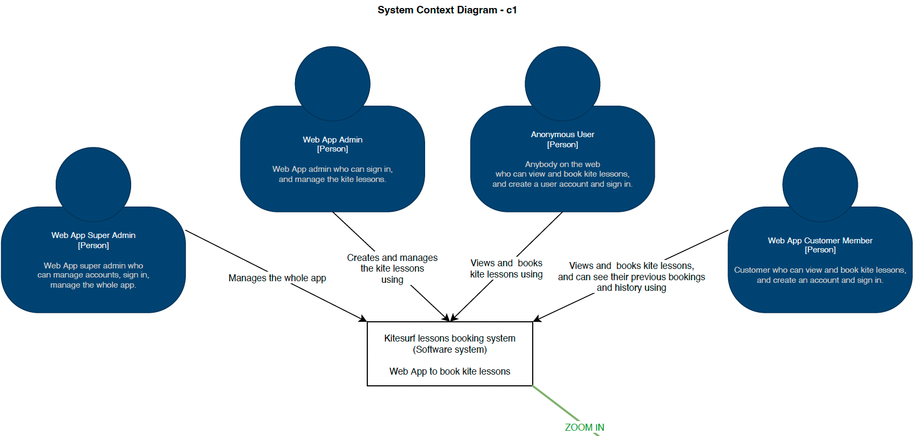

Container Diagram – c2

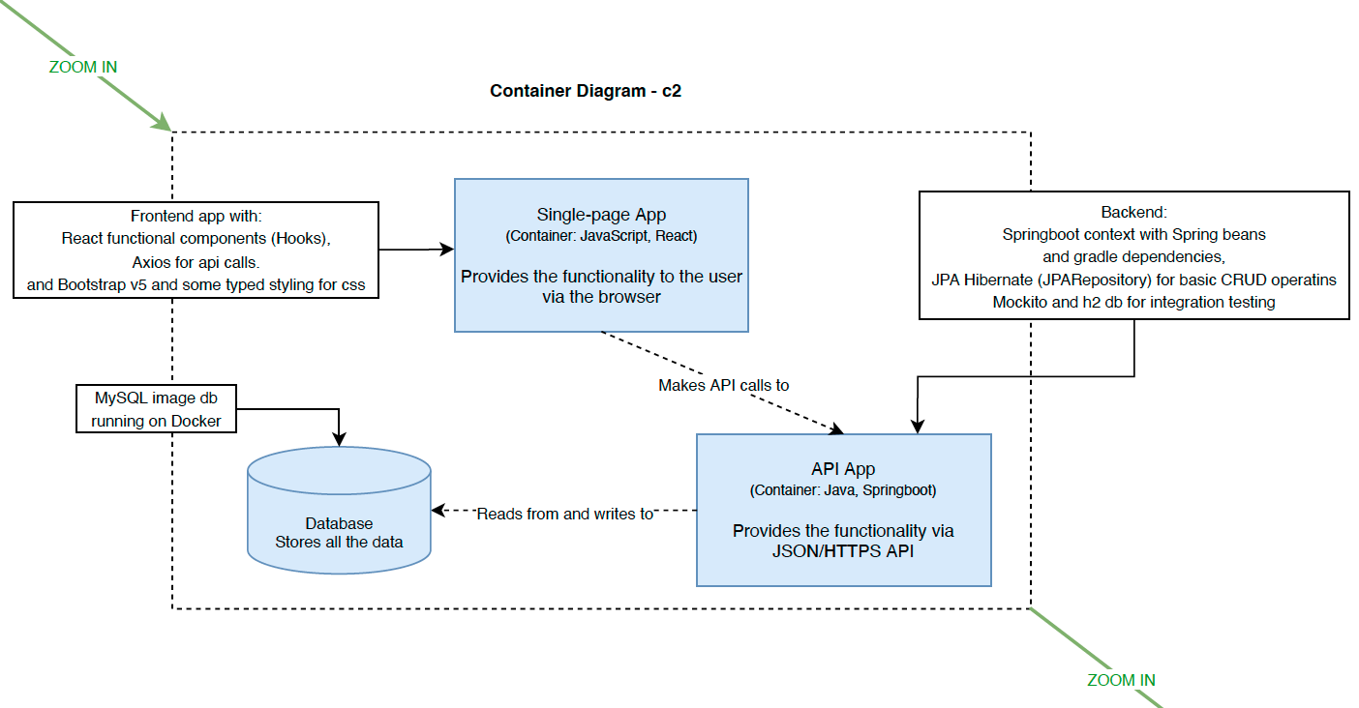

Component Diagram – c3

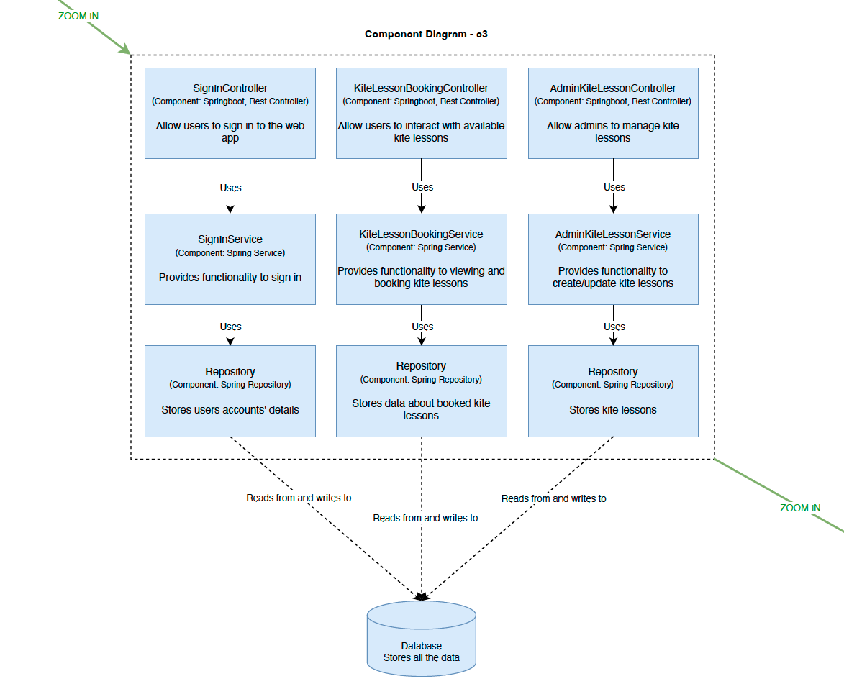

Class Diagram – c4

